**ASSIGNMENT 2 FRONT SHEET**

|  |  |  |  |
| --- | --- | --- | --- |
| **Qualification** | **BTEC Level 5 HND Diploma in Computing** | | |
| **Unit number and title** | Unit 30: Application Development | | |
| **Submission date** |  | **Date Received 1st submission** | 11/19/2019 |
| **Re-submission Date** |  | **Date Received 2nd submission** | 11/19/2019 |
| **Student Name** | Nguyen Trung Duc | **Student ID** | GCH17377 |
| **Class** | GCH0705 | **Assessor name** | Truong Cong Doan |
| **Student declaration**  I certify that the assignment submission is entirely my own work and I fully understand the consequences of plagiarism. I understand that making a false declaration is a form of malpractice. | | | |
|  |  | **Student’s signature** |  |

**Grading grid**

|  |  |  |  |  |  |  |  |
| --- | --- | --- | --- | --- | --- | --- | --- |
| P4 | P5 | P6 | M3 | M4 | M5 | D2 | D3 |
|  |  |  |  |  |  |  |  |

Table of Contents

List of tables: 2

List of figures: 2

Introduction: 2

I Peer review 2

Formal questionanarie 2

Feedback analysis 2

Suggestions and possible improvement 2

II Application development 2

2.1 Current system interface 2

2.2 Test case: 4

III Application review 4

3.1 Comparison to initial requirements 4

3.1.1 Functional features: 5

3.1.2 Non-functional features: 6

3.2 Assessment of the system’s strength and weakness 7

3.3 Indentified risks 7

Conclusion 7

References: 7

# List of tables:

# List of figures:

# Introduction:

In assignment 1, our team discussed and made decisions about the appropriate technologies and methods that will be applied in the FPT co (CMS) system. It is a blueprint that includes sections such as requirements, existing technologies and methods for managing and developing a cms system and, ultimately, an objective evaluation of the selection, to make the most appropriate decision.

 We have built a system based on the plan given earlier. In this section, we act as testers, perform system performance tests against initial requirements, conduct a small survey by the programmers, and evaluate the strengths. weaknesses as well as giving solutions.

# I Peer review

## Formal questionanarie

1. If you are to rate the cleanliness of the code, what will it be?

a.1*

b.2*

c.3*

d.4*

e.5*

2. On a scale of 1 to 5 how will you rate the web interface?

a.1*

b.2*

c.3*

d.4*

e.5*

3. On a scale of 1 to 5 how will you rate the web features?

a.1*

b.2*

c.3*

d.4*

e.5*

4. Presentation Skill

a.1*

b.2*

c.3*

d.4*

e.5*

5. Personal recommendation

6. What system features need improvements?

7. Problems needed to changed when selecting tools?

8. Is the scope and purpose of the system reasonable?

a. Yes

b. No

9. Evaluation of the display of the group on a scale of 1 - 5.

a.1*

b.2*

c.3*

d.4*

e.5*

10. Is the SRS Good enough?

a. Yes

b. No

c. May be

## Feedback analysis

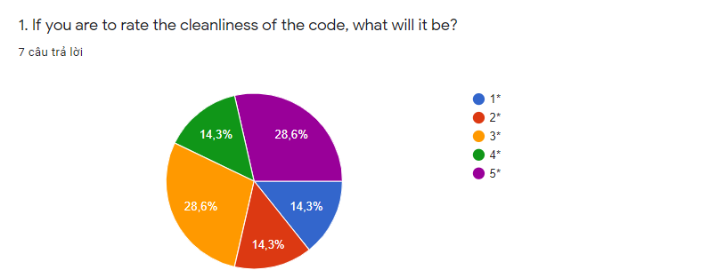

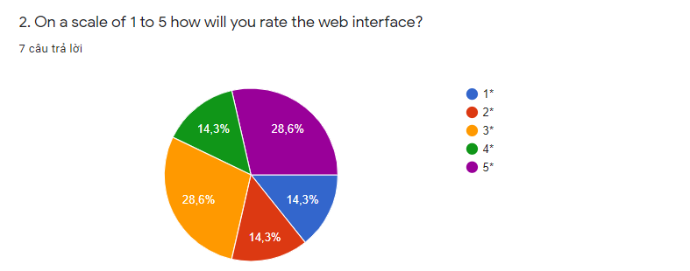

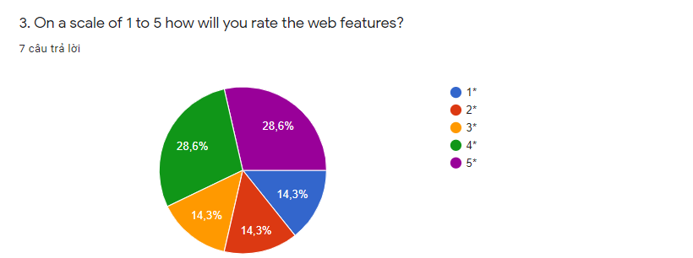

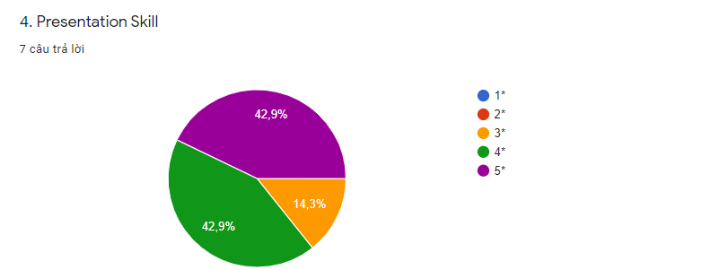

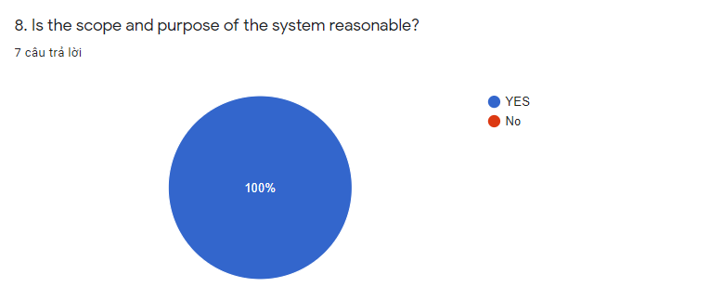

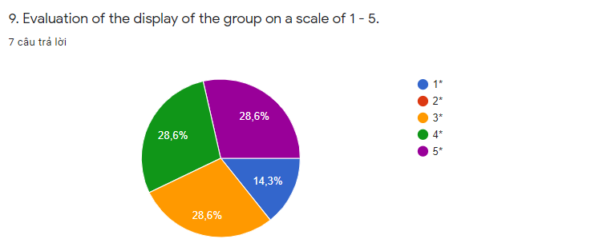

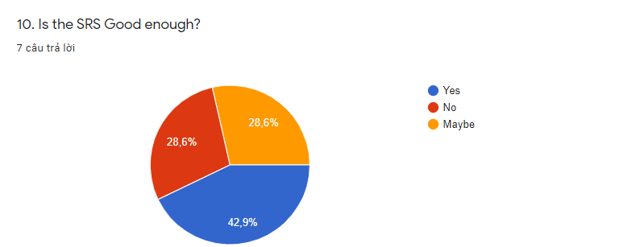

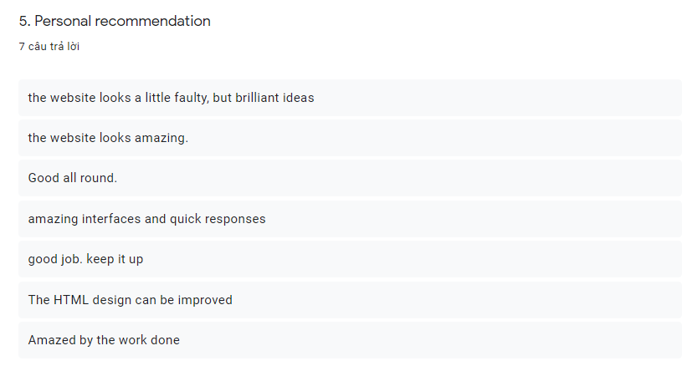

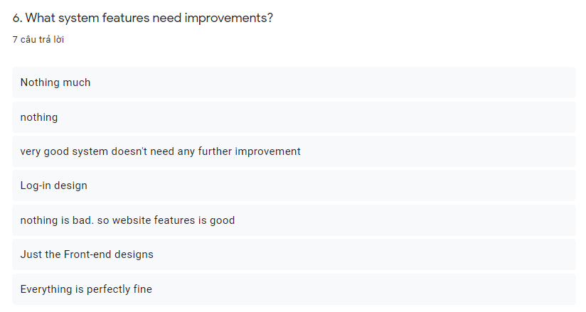

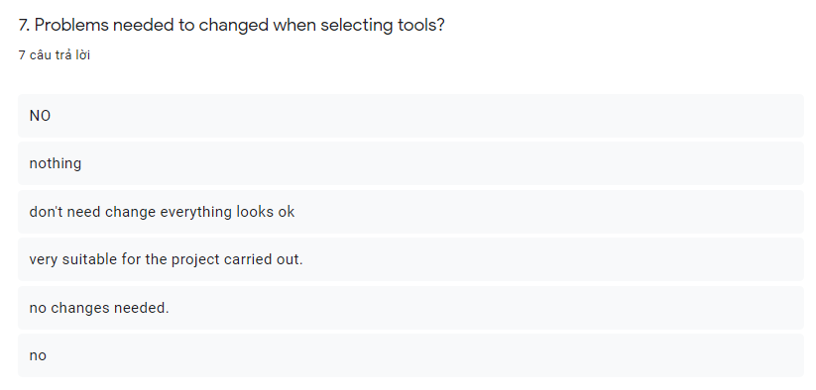

## Suggestions and possible improvement

# II Application development

## 2.1 Current system interface

The following is the educational management system for FPT employees. The interface is divided into 3 parts with specific roles

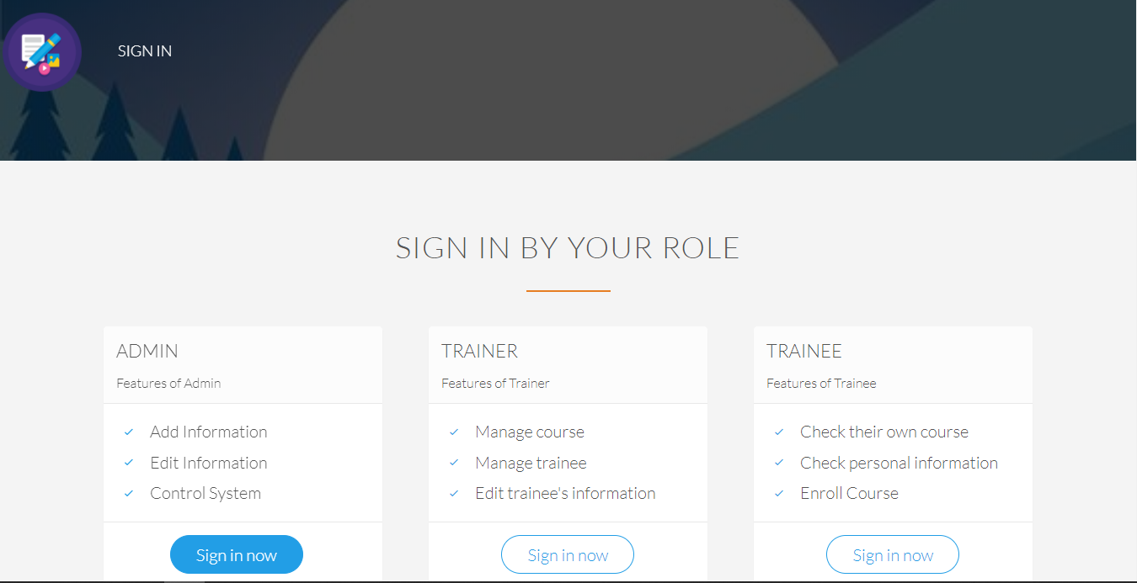

Admin:

Login function:

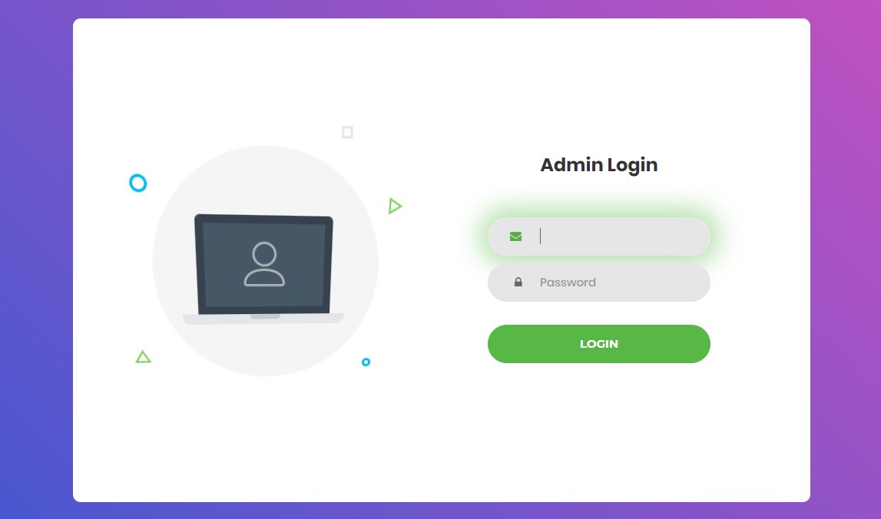

Home page of admin:



Adding new trainer account:

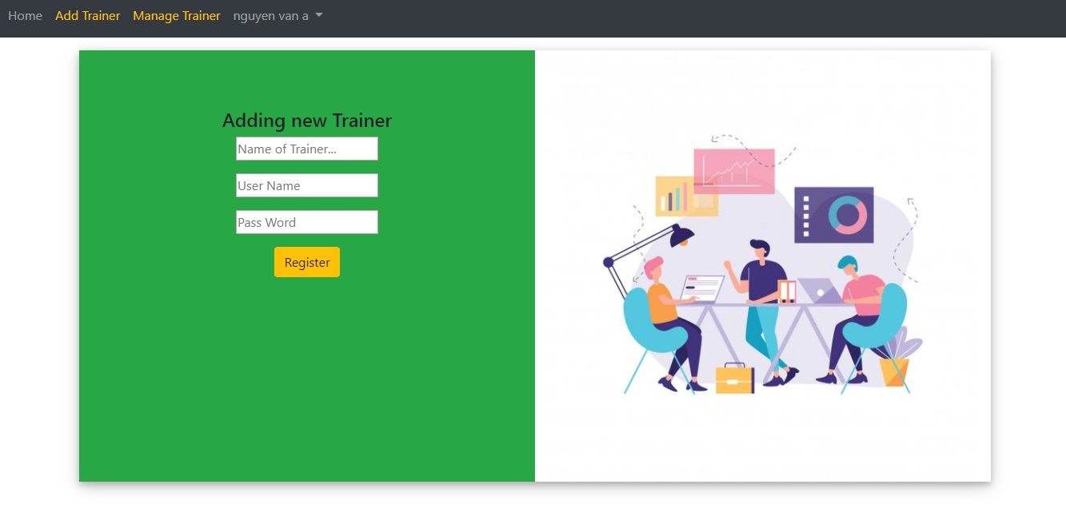

Management Trainer account:

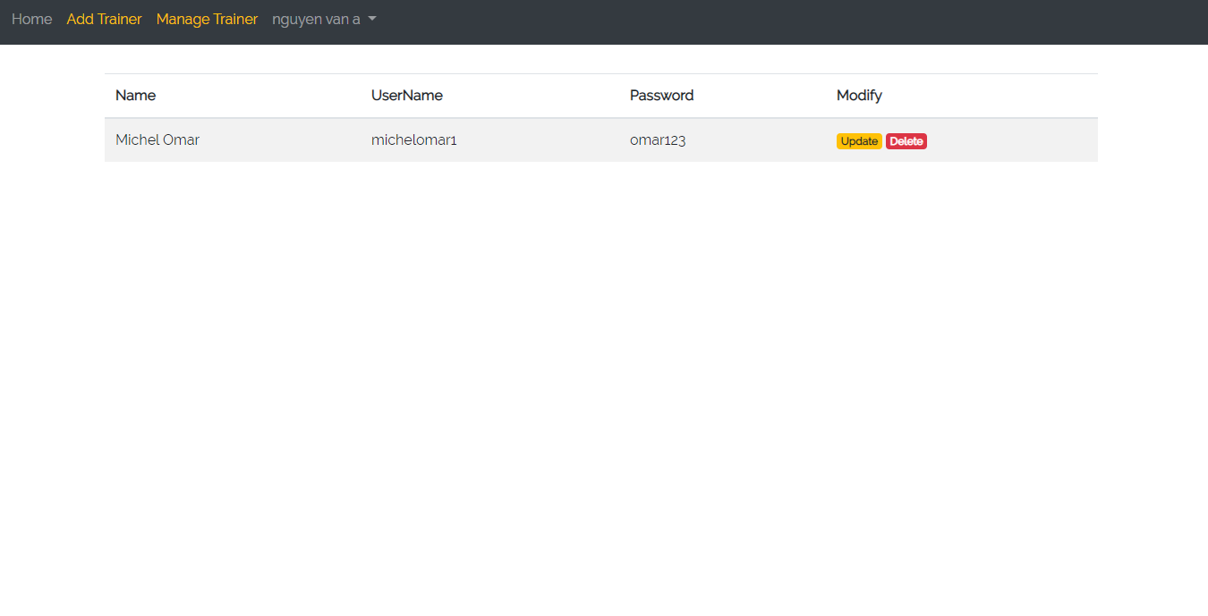

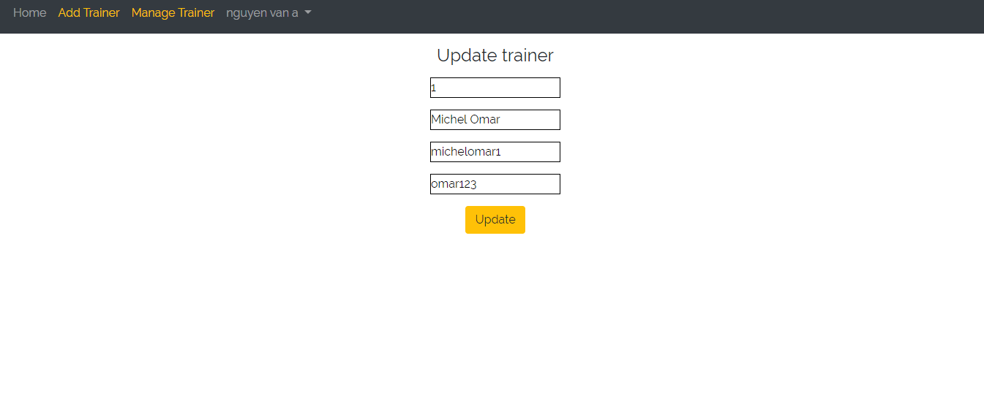

Trainer:

Login form of trainer:

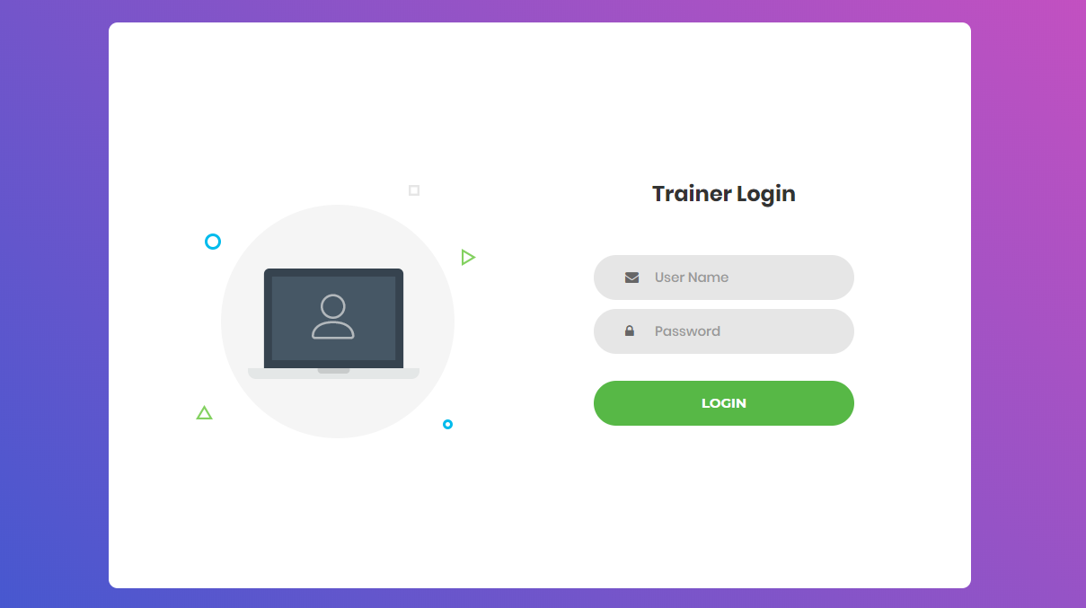

Home page of trainer:



Adding new Trainee account page:

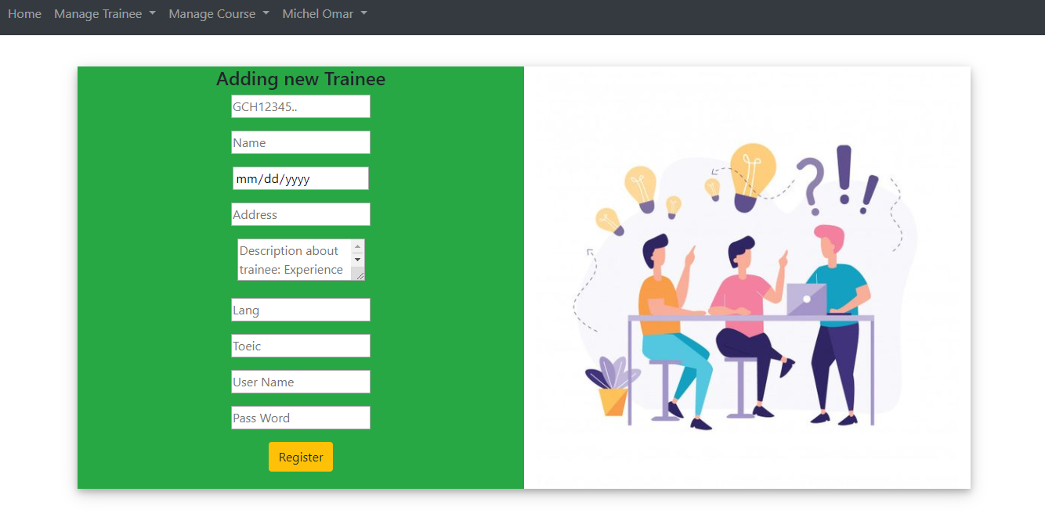

Management Trainee page:

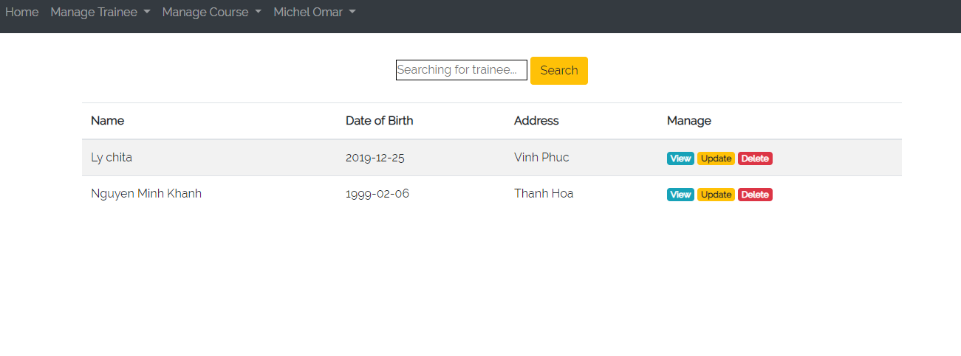

View detail trainee profile page:

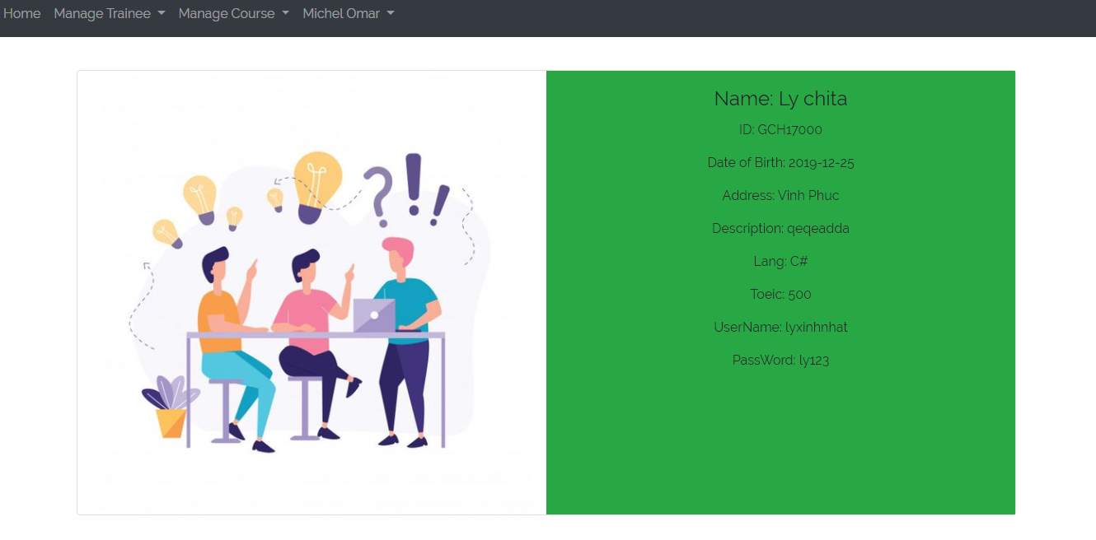

Update trainee profile page:

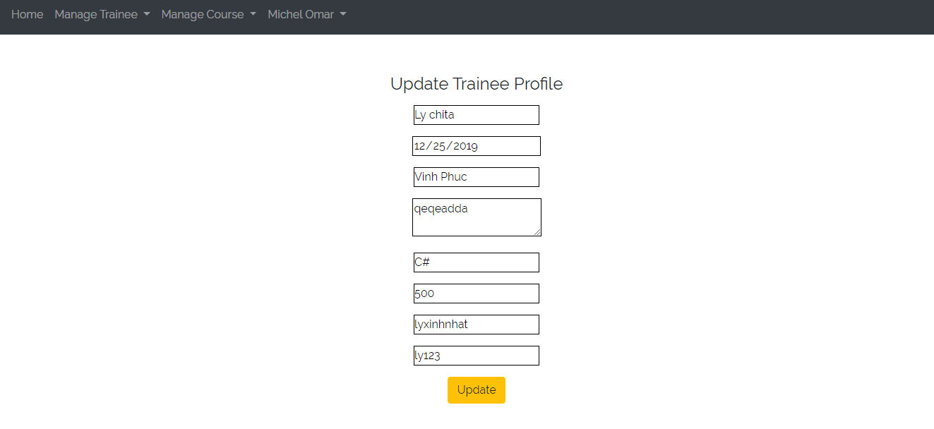

Management page for categories, courses:

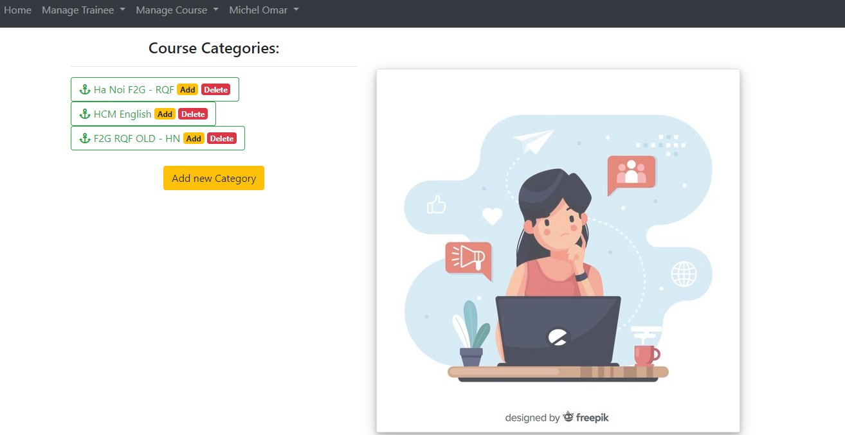

Adding new category:

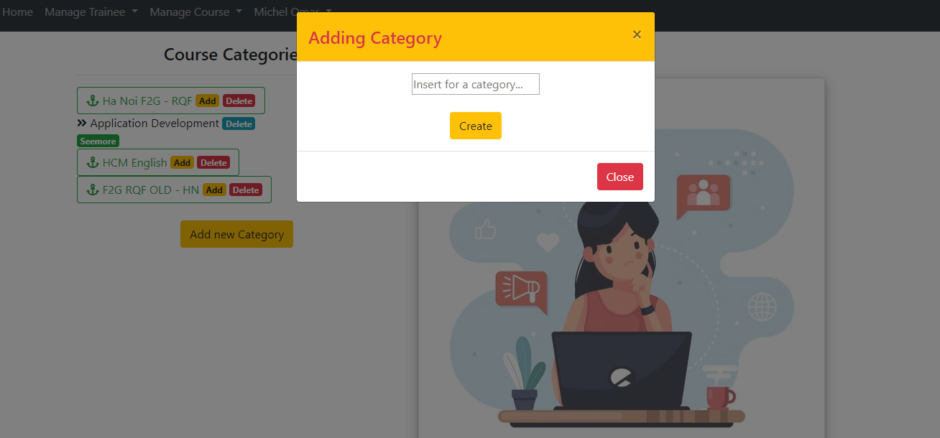

Adding new course:

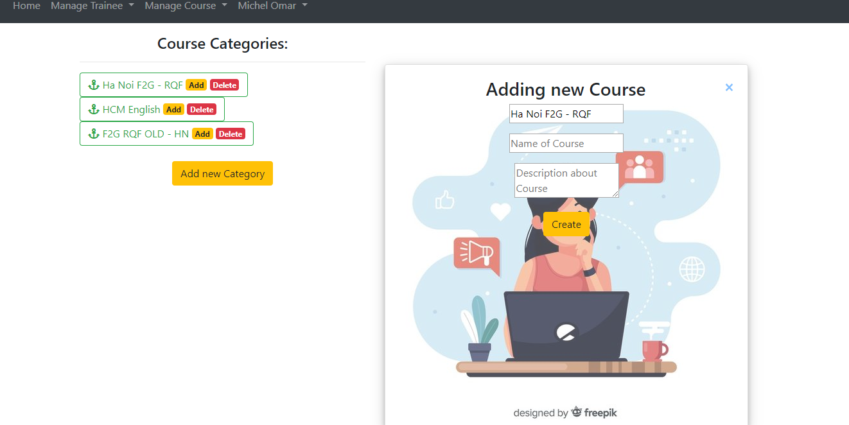

Management classes in course:



View class detail:



Adding new class:



Trainee:

Login form of trainee:

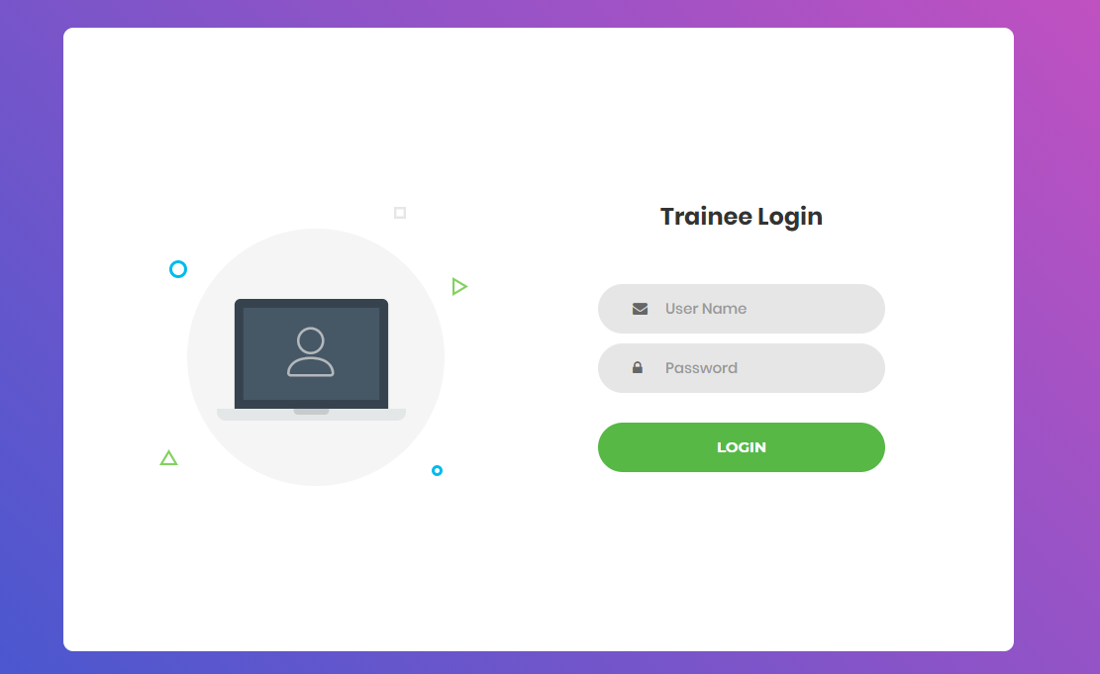

Home page of trainee:



View categories, courses, classes of course and registered class:

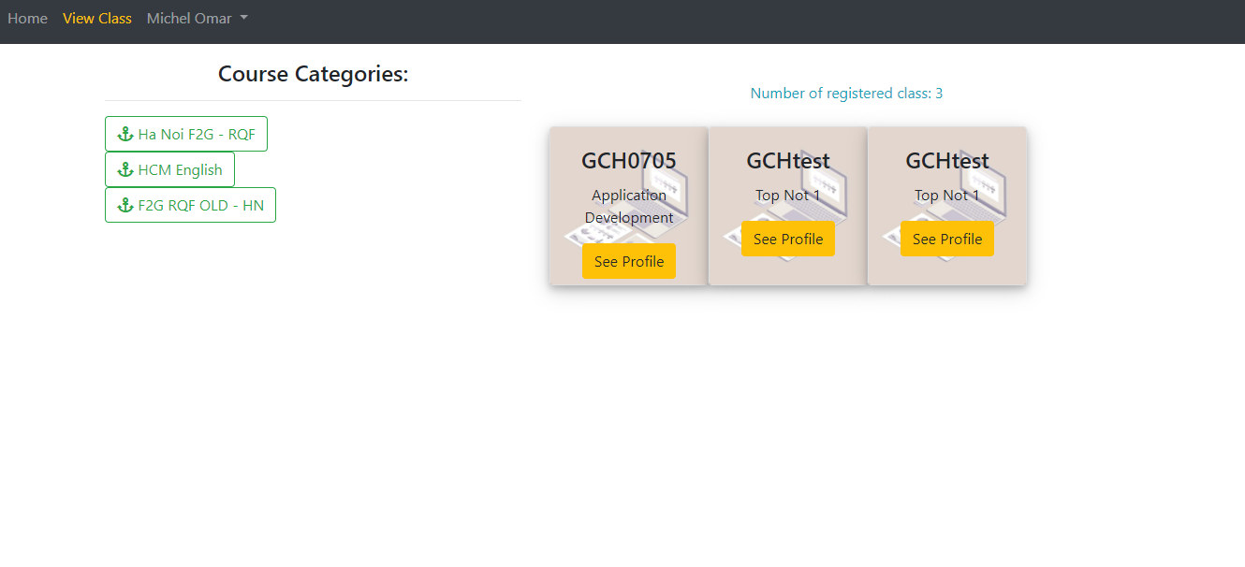

View topic in class:

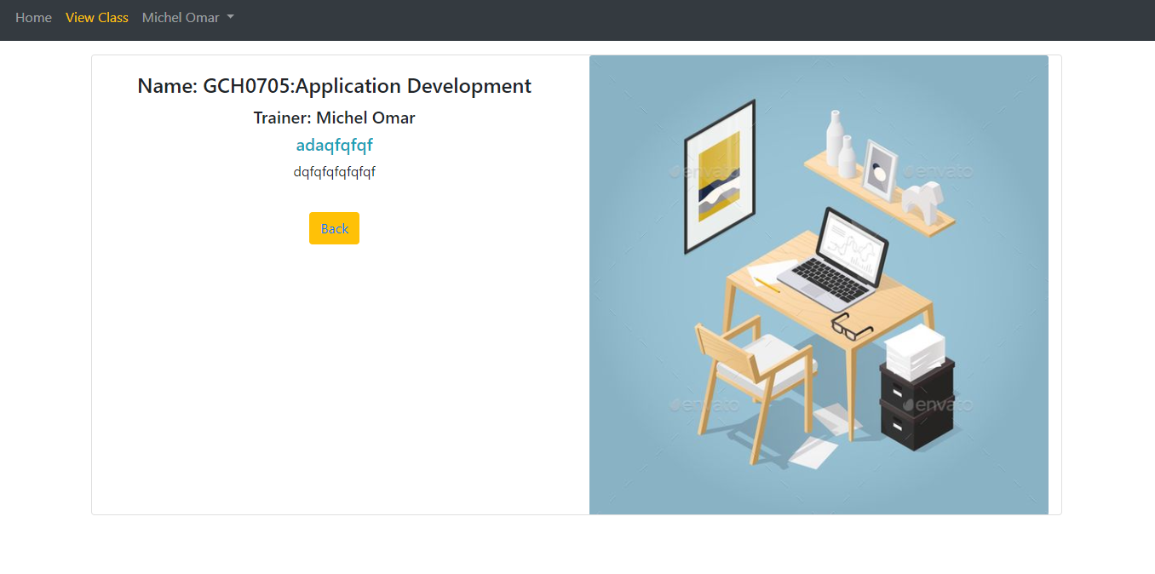

Register for a class:

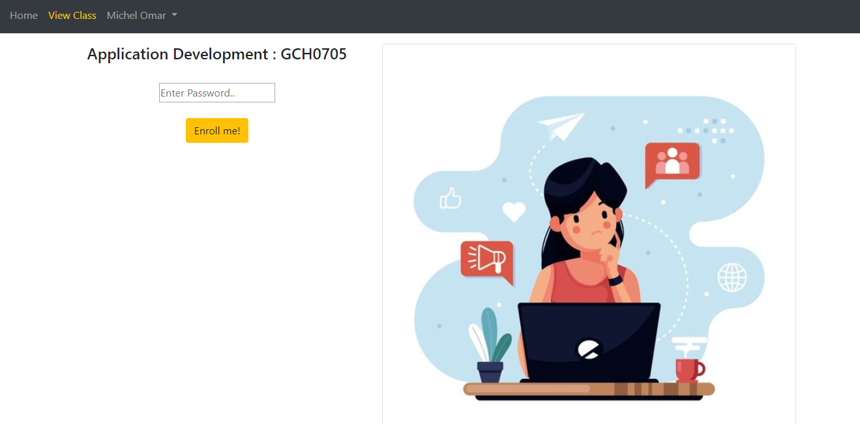

## 2.2 Test case:

## 2.2.1 Admin function testing:

|  |  |  |  |  |  |  |  |
| --- | --- | --- | --- | --- | --- | --- | --- |
| Function | What is being tested | How | Test data  used | Expected results | Time | Actual result | Action taken |
| Login function | Order of input  on data entry  screen | Enter the data following the instructions from the screen into the form with correct data | Data set:  Username: admin  Pass: admin123 | Logged in successfully | 12/31/2019 | OK | None |
| Login function | Validation of input | Performs a login without leaving any input values | Data set:  Leave the username blank | The system will issue a prompt to provide sufficient information | 12/31/2019 | OK | None |
| Login function | Sql injection | Enter values that generate sql errors | Data set:  Username:1' or '1' = '1  Password: 1' or '1' = '1 | Login unsuccessful | 12/31/2019 | OK | None |
|  |  |  |  |  |  |  |  |
|  |  |  |  |  |  |  |  |
|  |  |  |  |  |  |  |  |
|  |  |  |  |  |  |  |  |
|  |  |  |  |  |  |  |  |

## 2.2.2 Trainer function testing:

## 2.2.3 Trainee function testing:

# III Application review

3.1 Comparison to initial requirements

After the development of the first version of the system has been completed, we will continue to sit back to check that the system's functions and non functional features meet the needs of FPT. The below directly compares the current system requirements and functions.

### 3.1.1 Functional features:

Admin:

|  |  |  |  |  |
| --- | --- | --- | --- | --- |
| Function | Initial requirement | On track | Conclusion about function of system | |
| 1 | Can login to the system through the first  page of the application | 100% | | We have designed a login interface exclusively for the admin. Here with username and password, admin can log into the system easily. In addition, the system has features that validate not allowed and prevent sql injection | |
| 2 | Can create and manage new user account for trainer (edit/delete) | 100% | | After making login. List of trainer accounts is displayed with delete or update options with information such as name, username, password. The function meets the requirement | |

Trainer:

|  |  |  |  |
| --- | --- | --- | --- |
| Function | Initial requirement | On Track | Conclusion about function of system |
| 1 | Can login to the system through the first  page of the application | 100% | We have designed a login interface exclusively for the Trainer. Here with username and password, trainer can log into the system easily. In addition, the system has features that validate not allowed and prevent sql injection |
| 2 | Can add new user account for trainee | 100% | After making login. Administrators can create a new trainee account with information such as trainee name, trainee accounts, age, date of birth, education, main programming language, TOEIC score, experience details, department, location, etc. on an easy web interface easy. Besides, the error values are also valid at the input. |
| 3 | Can save the information of trainee accounts in the database and from the list of trainees searchable by programming language keywords, TOEIC score etc | 80% | All information from the trainee account after being created by the trainer is saved in the database. When needed, it is easy to search by the name of the trainee. However, we still lack the invalid value validating features. |
| 4 | Can update, delete trainee accounts | 0% | Trainee cannot edit his own profile, he has to rely on the admin |
| 5 | Can manage categories such as searching, adding, updating and deleting course categories | 75% | The system provides trainers with features for managing adding and deleting categories. But there is no updating feature yet |
| 6 | Can manage courses such as searching, adding, updating and deleting courses | 75% | The system provides trainers with features for managing adding and deleting courses. But there is no updating feature yet |
| 7 | Can add topics such as topic name and topic descriptions into a course, add courses into a category | 100% | The trainer can create new topics and descriptions for a new class after performing the login session. |
| 8 | Can manage trainer profile such as adding, updating and deleting the information | 0% | The Trainer cannot directly edit his profile on our system but must rely on the admin. |
| 9 | Can assign trainer to a topic | 100% | Trainer can register teachers for specific classes on the system |
| 10 | Can assign trainee to a course | 0% | The system does not have this feature |

Trainee:

|  |  |  |  |
| --- | --- | --- | --- |
| Function | Initial requirement | On track | Conclusion about function of system |
| 1 | Can login to the system through the first  page of the application | 100% | We have designed a login interface exclusively for the Trainee. Here with username and password that resigntered by trainer, trainee can log into the system easily. In addition, the system has features that validate not allowed and prevent sql injection |
| 2 | Can view courses which have a topic he is assigned to | 75% | Trainee can view the class that you have registered on the system. There is no feature registered by the trainer |
| 3 | Can update own profile | 0% | The system does not have this feature |

### 3.1.2 Non-functional features:

In this section we will continue to compare the existing non-funtioncal features in the system with the initial requirements in terms of performance, security, UX / UI, etc:

|  |  |  |  |
| --- | --- | --- | --- |
| Non-function features | Initial requirement | On track | Conclusion |
| UX/UI | The system needs to provide a nice user friendly interface. | 100% | Our system provides a beautiful interface, selected colors are very bright, using trendy designs such as gadient, bootrap, jquery. Besides, the interface is easy to use and not tangled, users always take the control role with the nav which is located at the top of the website. Logical user script, and there's always a navigation button to go back or show what to do next. |
| Performance | Website response time is short | 75% | Using MVC model helps the website wait time for response from 0.2 to 0.5 seconds. However, the code is not really clean, increasing the highest speed |
| Security | Ensuring information security and safety features, preventing hackers from infiltrating and stealing information. | 50% | The security features available on the site are prevention of sql injection, html and javascript code. However, the biggest minus point is that it has not done data encryption before putting into the database, which poses great risks to customer privacy. |
| Capacity and expandability | The system can cater to about 1,000 people or more | 10% | Currently the system has not provided the domain name, so it is not possible to grasp the ability to store and expand on the cloud |

## 3.2 Assessment of the system’s strength and weakness

Advantage:

Disadvantage:

## 3.3 Indentified risks

Lo hong bao mat, (loi-giai phap)

# Conclusion

# References:

|  |  |  |
| --- | --- | --- |
| **❒ Summative Feedback: ❒ Resubmission Feedback:** | | |
| **Grade:** | **Assessor Signature:** | **Date:** |
| **Lecturer Signature:** | | |